Introduction

With regard to the main purpose of “Assignment 1: Simple CV Portfolio” (CSY1018) which are:

1. Create your own personal portfolio in order to support your employability
2. Work with HTML5 and CSS,

The report is comprised of the main developmental structure and their overall changes throughout the making of my portfolio.

Rather than jumping into the making of my design decisions and starting off with the coding part of my portfolio directly, I decided to go step by step. The first step would be to do some research and planning for my portfolio. The websites I took inspiration from are:

<https://twitter.com/joelyuk>

<https://www.visualcv.com/examples/it/>

The step could assist me to picture how my website should actually be looking like but to be honest this step end up creating complexities for me as the websites were actually designed by the professionals. For a starter choosing to go step by step in a simple way would be best. Thus, I decided to first start with the basic design and build it up.

Sketches of the WebPages

* Homepage sketches

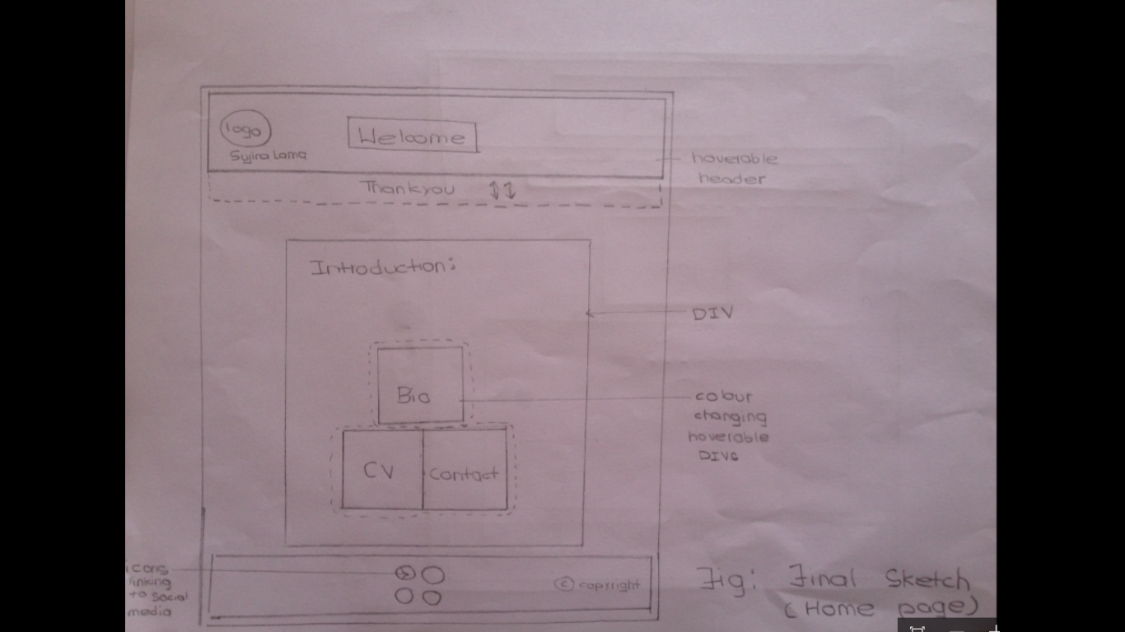

My homepage will be simple yet different. Starting with the header, it will include the logo and me at its left side and some greetings will also be included. I always loved the idea of hoverable dropdown menu that we have in our smart phones. Thus, the header will be hoverable, displaying thank you message, which will be replaced by navigation bar in other pages. The footer will simply include some social media linked icons and copyright text.

The prime focus goes to the main components (links of the Bio, CV and contact pages). They will be kept inside the DIVs in triangular arrangements inside another main DIV and have hoverable button like effect when the user places the pointer on them. Right above the DIVs, there will be short introduction of mine and the homepage.

* Bio page sketches

The Bio page will have the similar hoverable header which displays the navigation bar having the links to (home, CV and contacts) pages in a row. Right below the header, an image will be added in the middle, following that will be my short biography placed in a DIV. The footer will be similar to that of home page.

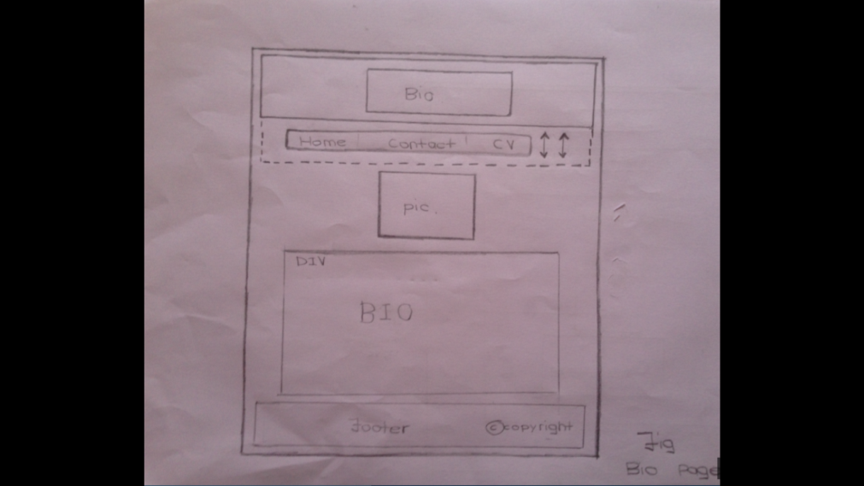

* CV page sketches

The header and the footer of the CV page will be similar to that of the bio page; only the link to the CV in the navigation bar will be replaced by bio page link. The different sections i.e. education, experience, courseworks etc. will be placed in 2 columns. Each section will have its own DIV.

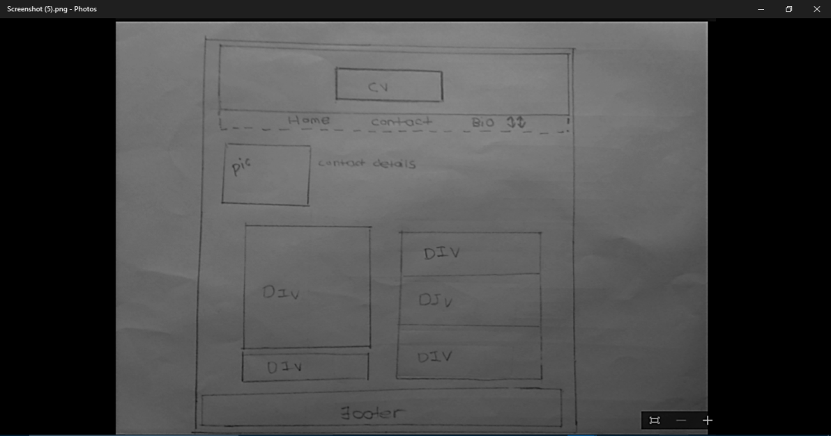

* Contact page sketches

The navigation bar will have the link to the home, bio and CV pages. The header and footer will have no change. The page will have a form and a DIV including the contact details where some icons will also be considered.

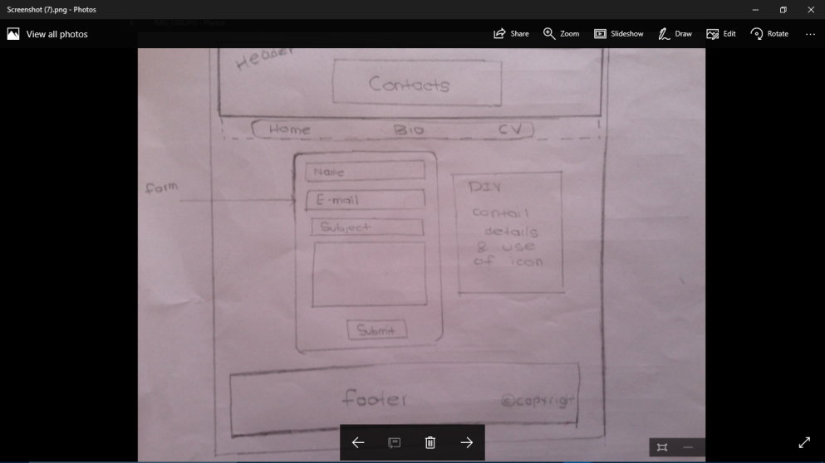

Wireframes of the WebPages

* Index page Wireframe

Header (Hover able)

[Greetings]

(Hidden message)

(Hidden message)

Main DIV

Small introduction

Equal sized DIV1

Equal sized DIV2

Equal sized DIV3

Footer

Icons

* Bio page wireframe

My picture

DIV

Short biography

Footer

Header (Hover able)

Navigation bar (hidden)

* CV page wireframe

Navigation Bar (hidden)

Header (Hover able)

Footer

DIV

(Section)

DIV

(Section)

DIV

(Section)

My picture

DIV

(Section)

DIV

(Section)

Full name &

Contact details

* Contact page Wireframe

Footer

DIV

Contact details

Form

Navigation bar (hidden)

Header

Progression of the website

1. 1-4 weeks

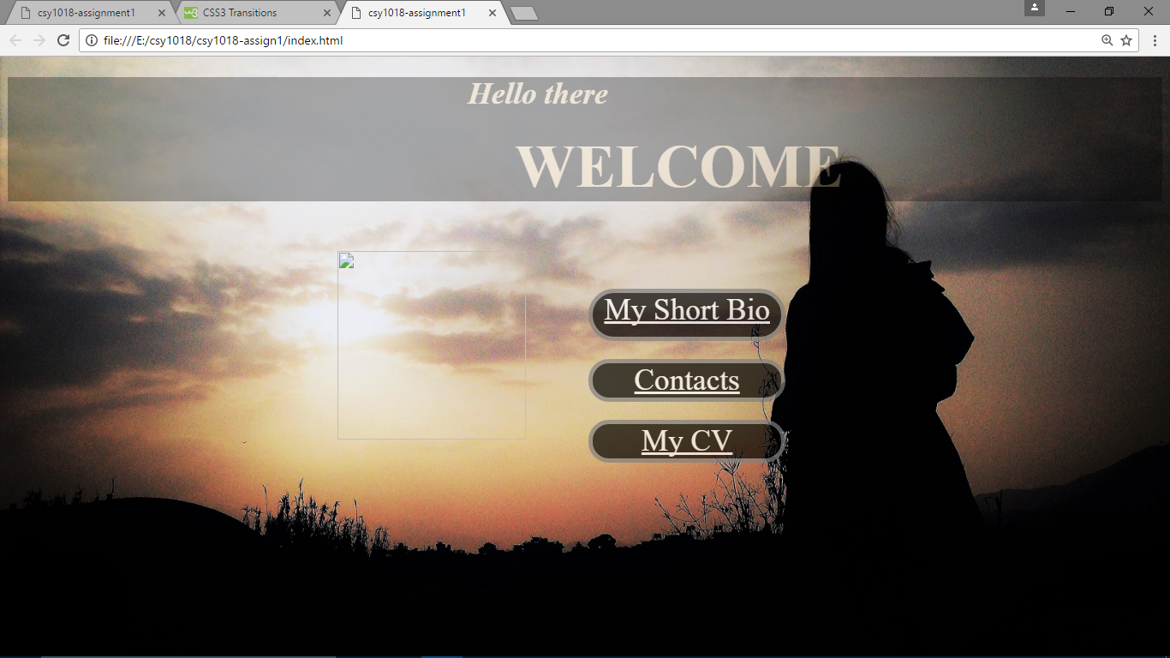

Fig 1. First 2 weeks of working on Homepage

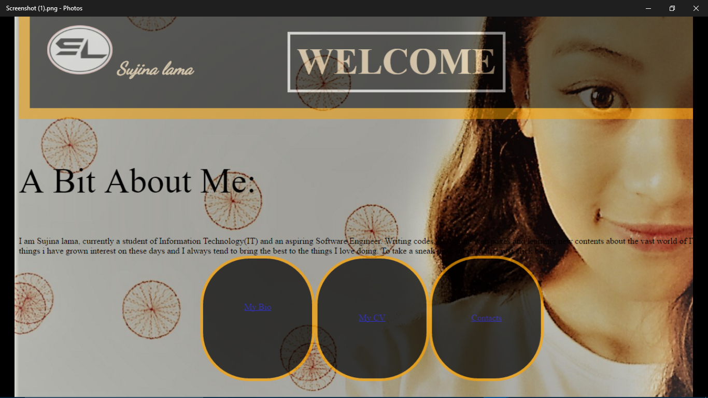

Fig2. Last 2 weeks of a month on Homepage

I started my working from the designing of the Index page. I decided to create the header and the DIVs first. The first picture represents my webpage before 2nd week, where it can clearly be seen that the header is simple with no DIVs placed in its position as planned. The DIVs contains the links to the Bio, CV and contact pages respectively.

The second picture represents the webpage after 2nd week. I mainly worked on its CSS where in header; I placed the logo at its left with my full name after providing it an orange border. The ‘Welcome’ text was given a white border after placing it in the separate DIV. Flex property is also used; DIVs containing links are arranged in a row. A short introductory part has also been added above the DIVs and the background image is changed. Overall, drastic changes have been made.

1. 4-8 weeks

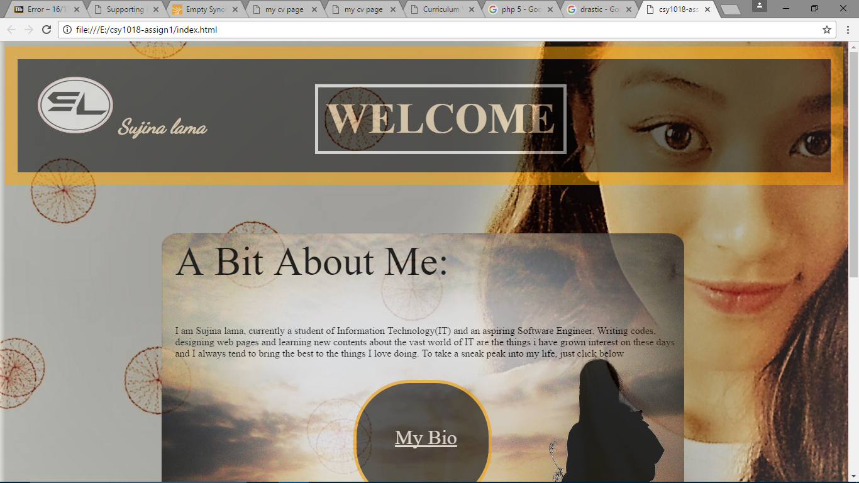

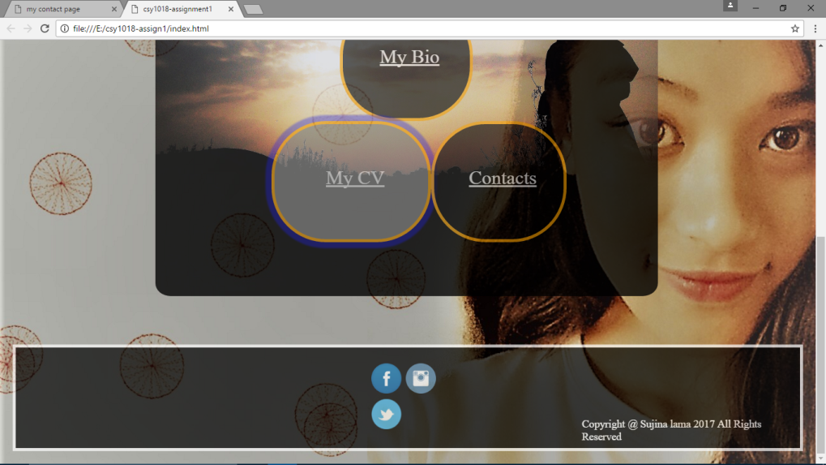

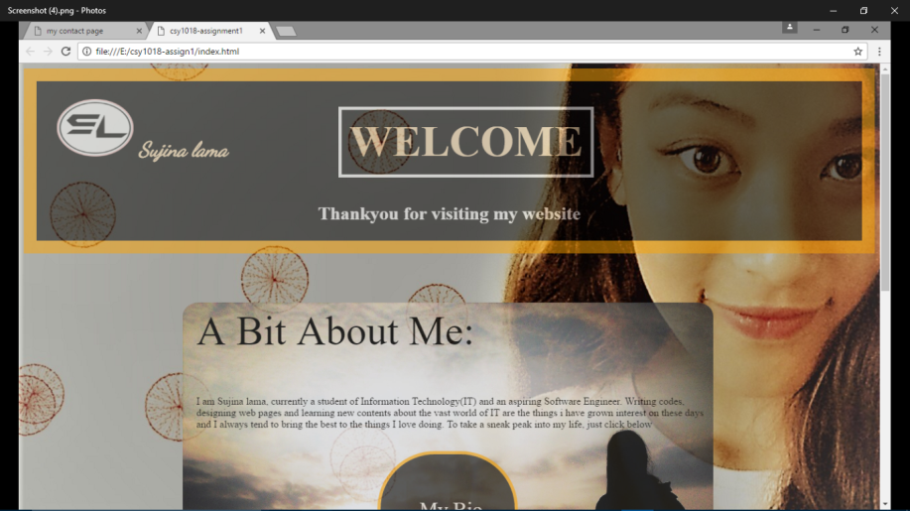

Fig: Webpage with header on hover

During 4th-6th weeks, continuing my working on homepage, there is a change in header as it is made hoverable and the short introductory part and the DIVs are placed inside another DIV which is placed right in the middle of the webpage which was achieved after assigning its height, width and padding to it. DIVs, which was previous in a row is changed into the triangular arrangement. The footer having the icons and the copyright text has also been created.

This is the Bio page that I created during 6-8 weeks. I wrote my short bio first and kept it inside the DIV and determined its height and width. In its CSS, I used the gradient background.

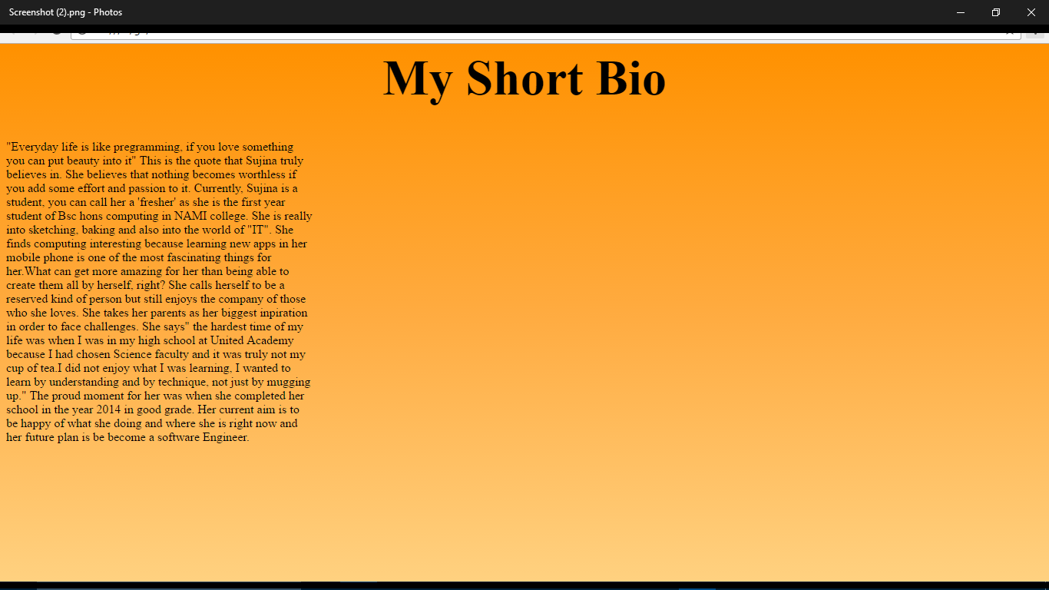

1. 8-12 weeks

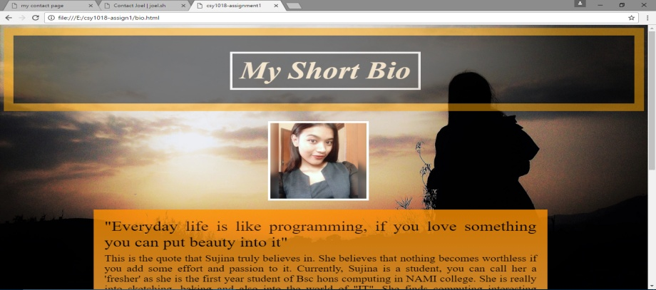

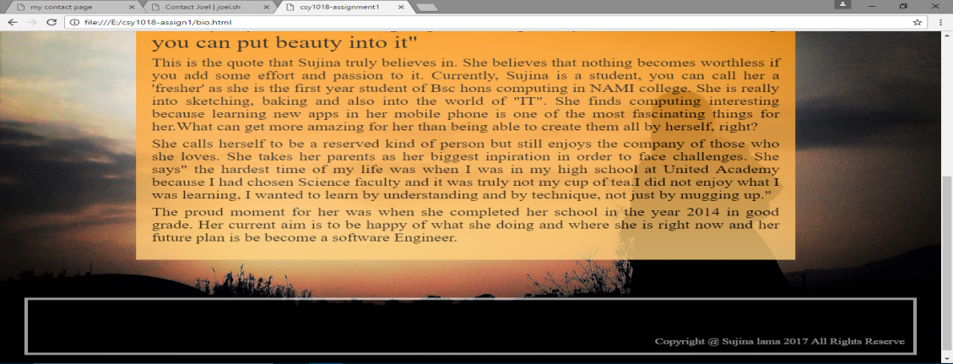

I added the header and footer along with an image and DIV containing my short bio. I worked with the padding and aligning of the text and added navigation bar which gets visible after placing the pointer on the hoverable header.

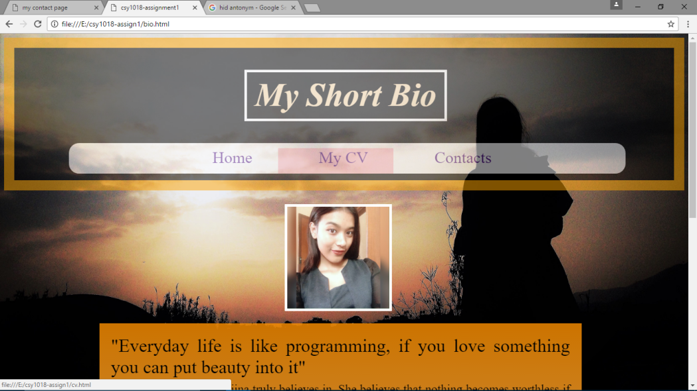

Fig: Visible Navigation Bar

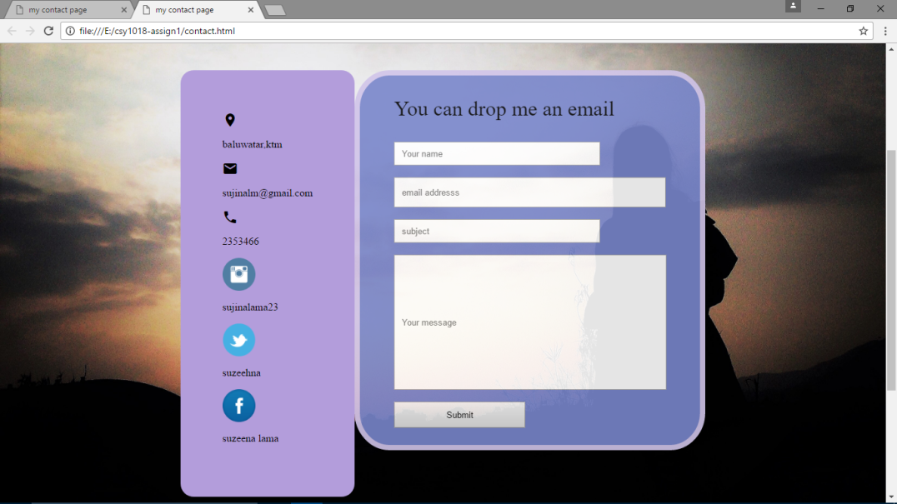

Then I created my contact form, as shown, at left, there is a DIV containing all my contact details in column and icons has also been used to make it attractive. At the right, there is a form where name, email, subject and message can be inserted and submitted.

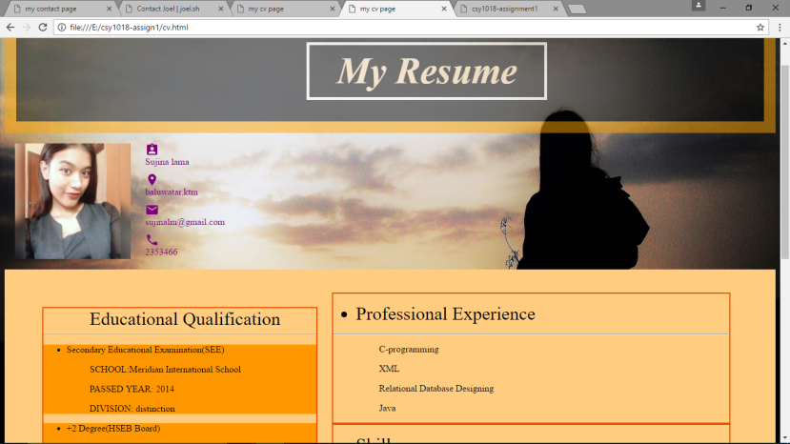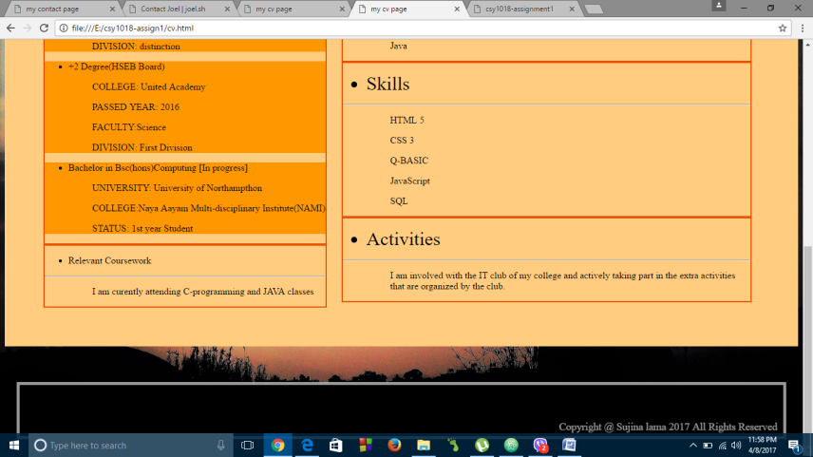

10th week, I worked on my CV page, the hoverable header, footer and background are similar to that of Bio page. Only the main content that is the different sections are placed in 2 columns and each in different DIVs and the whole DIVs are placed inside another main DIV. A picture of mine with some contact details can be seen at the left, below the header. ‘Material design guidance’ has been used by adding different colors to the texts.

1. Making the WebPages responsive

By using the HTML and CSS we can be able to make any web pages responsive i.e. we can resize, shrink or enlarge it in any devices. I made all of my pages except Index page responsive by using RWD Media Queries. While in responsive mode, the hover effect in header gets removed and the navigation bar is in column. The icons in the footer also get arranged in a column. The DIVs and images are resized according.

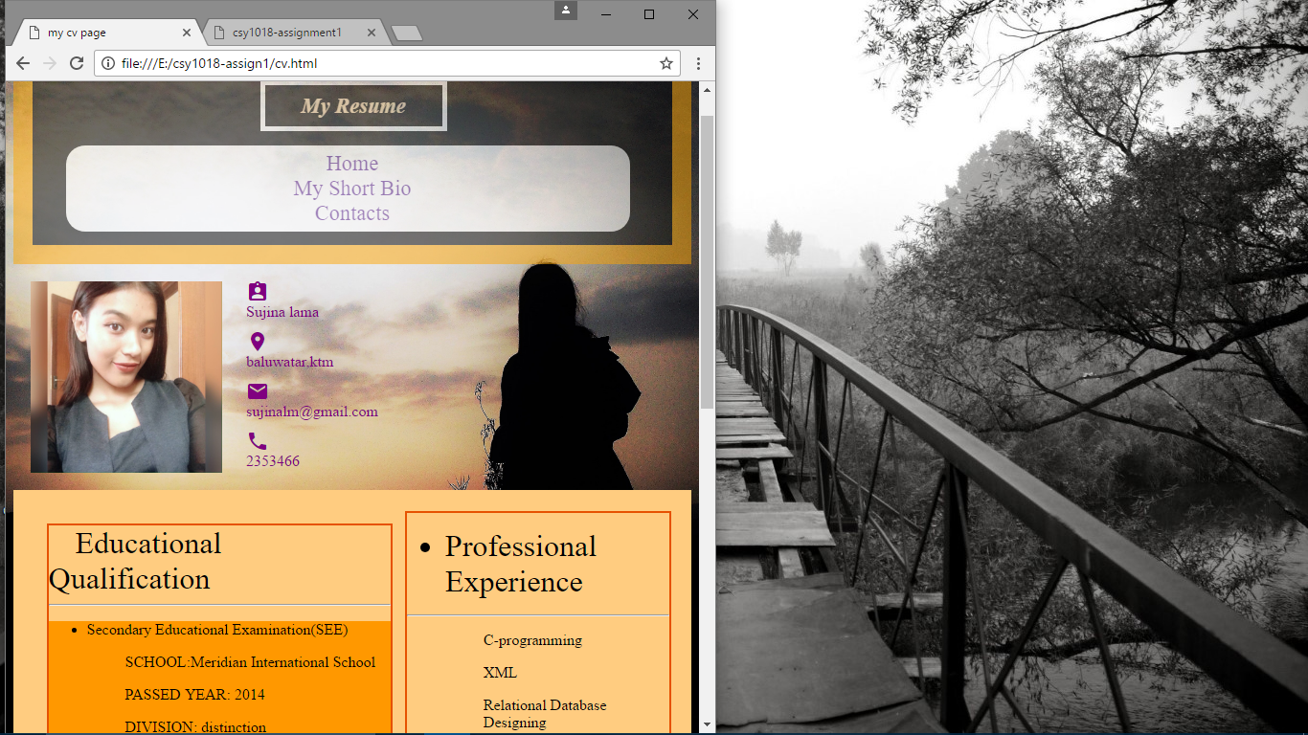

Fig: Responsive CV page

Website speed test

